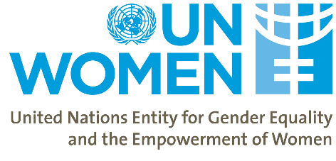
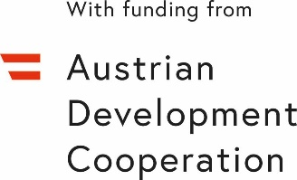
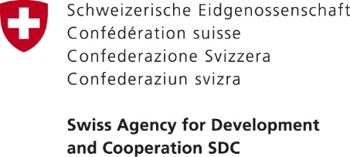

Equal Pay International Coalition (EPIC) – Taking Steps towards Closing the Gender Pay Gap in Georgia

Date: | September 18, 2020
Location: | Zoom Meeting (https://bit.ly/33plRaZ)
Organizer: | UN Women
Participants/target audience: | The event will bring together representatives of the government, private sector, trade unions and civil society from Georgia and Armenia to review the Gender Pay Gap (GPG) situation in both countries and on-going or planned interventions to close the Gap.
Expected outcomes: | - Discuss Gender Pay Gap problem in Georgia and Armenia based on UN Women/SDC/ADA GPG studies.  - Increase public awareness of the commitments made by Georgia to close the Gender Pay Gap by joining EPIC.  - Participants discuss the role of various actors in addressing the GPG and review international best practices that can inform policymaking in Georgia and Armenia

BACKGROUND
Equal pay is one of the targets of the 2030 Agenda for Sustainable Development, which recognizes it as a key to inclusive growth and poverty reduction. Sustainable Development Goal 8 calls for the promotion of sustained, inclusive and sustainable economic growth; full and productive employment; and decent work for all. Equal pay is also addressed in the Beijing Declaration and Platform for Action (BPfA) as one of the indicators for women’s empowerment. Georgia has committed to fulfilling the obligations indicated by these international instruments.

The (active) Labour Code of Georgia – as the primary regulatory framework for employment relationships – does not cover the equal pay principle, nor does it specify the notion of direct and indirect discrimination. According to the International Labour Organization (ILO) Committee of Experts, the Georgian national courts have reported no cases regarding equal pay between men and women. The Committee assumes that when no cases or complaints are being lodged it is likely to indicate a lack of an appropriate legal framework, a lack of awareness of rights, a lack of confidence in, or absence of, practical access to procedures, or a fear of reprisals. The Labour Code is currently under-going a reform process and the proposed draft includes a definition of discrimination based on pay (however, this may not be the final draft that is approved).

The celebratory event is organized in the framework of the project “Women’s Economic Empowerment in the South Caucasus” (WEESC) funded by the Swiss Agency for Development and Cooperation (SDC) and Austrian Development Cooperation through the Austrian Development Agency (ADA) and implemented by UN Women. The objective of the event is to provide a platform to discuss Georgia’s commitments to the EPIC and addressing the Gender Pay Gap (GPG). The primary focus of the event is to further raise awareness around the EPIC as well as on the Government of Georgia’s commitments and plans to close the Gender Pay Gap. The event will also discuss the role of social partners in addressing the GPG aiming to increase the motivation of private sector / employers and trade unions to join EPIC.

The event will gather representatives from the Parliament of Georgia, the government agencies that are involved in policy level decisions, data production and analysis on the GPG from Armenia and Georgia (i.e. Ministry of Economy and Sustainable Development (MoESD) of Georgia; Department of Labour under the Ministry of Internally Displaced Persons from the Occupied Territories, Labor, Health and Social Affairs (MoIDPOTLHSA) of Georgia; GEOSTAT; and (depending on the epidemiological situation and international travel restrictions) representatives of the Ministry of Labour and Social Affairs of Armenia; and ARMSTAT. In addition, the event will include representatives from the Trade Unions and Employers’ Associations of Armenia and Georgia and key civil society organizations.
Due to the epidemiological situation the event will be held fully online.

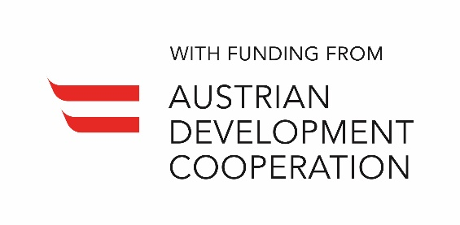

Equal Pay International Coalition (EPIC) – Taking Steps towards Closing the Gender Pay Gap in Georgia
Agenda

Venue: Zoom Meeting (https://bit.ly/33plRaZ)

Date: September 18 2020

Time: 13:30 – 15:40 GMT+4

Time | Agenda Item
13:30 – 14:00 | Opening remarks  Panel hosted and moderated by Dr. Sabine Machl, UN Resident Coordinator, Georgia  - Ms. Tamila Barkalaia, Deputy Minister, Ministry of IDPs from the Occupied Territories, Labour, Health and Social Affairs of Georgia  - Ms. Lela Akiashvili, Prime Ministers Advisor on Human Rights and Gender Equality Issues, Government of Georgia  - Ms. Tatevik Stepanyan, Deputy Minister, Ministry of Labour and Social Affairs of the Republic of Armenia  - Dr. Sylvie Durrer – Director, Swiss Federal Office for Gender Equality  - Dr. Danielle Meuwly, Regional Director, Swiss Cooperation Office for the South Caucasus  - H.E. Mr. Thomas Muehlmann, Ambassador of Austria to Georgia
14:00 – 15:30 | Panel Discussion: Gender Pay Gap challenge and how to join forces to close it  Moderator: Ms. Tamar Sabedashvili, Country Representative a.i., UN Women  - Gender Pay Gap situation in Georgia, Mr. Vasil Tsakadze, Head of Social Statistics Department, National Statistics Office of Georgia  - Gender Pay Gap situation in Armenia, Ms. Lusine Kalantaryan, Head of Labour Statistics Division, Statistical Committee of Republic of Armenia  - Addressing Gender Pay Gap, lessons from Switzerland, Dr. Oliver Schröter, Economist and Expert on Equal Pay, Swiss Federal Office for Gender Equality  - Measures foreseen by the Ministry responsible for Labour to address the Pay Gap, Ms. Tamila Barkalaia, Deputy Minister, Ministry of IDPs from the Occupied Territories, Labour, Health and Social Affairs of Georgia  - The work of the Trade Unions around the Gender Pay Gap, Raisa Liparteliani, Vice-President, Georgian Trade Union Confederation  - The role of employers to address the Pay Gap (Representative of Employers’ Association, Georgia) TBC  Q&A session
15:30 – 15:40 | Closing remarks  Ms. Lela Akiashvili, Prime Ministers Advisor on Human Rights and Gender Equality Issues, Government of Georgia

